Jamie Warner – Principal jwarner@lwsd.org
Rebekah Westra – Associate Principal rwestra@lwsd.org
Gary Wilson – Office Manager gwilson@lwsd.org
Kellie Eaton – Secretary keaton@lwsd.org

Samantha Smith Elementary School
23305 NE 14th Street Sammamish, WA 98074-4441
Office: (425) 936-2710 Fax: (425) 836-8258

Hello Smith Family,
Please be sure to read all school emails starting August 2nd.
The first day of school this coming year for 1st-5th grade is Wednesday, September 1st.
The first week of school will be Family Connection Meetings for our kindergarten students. (September 1st, 2nd, 3rd, 7th). First day of Kindergarten is September 8th.
This year, you can expect an email from the school with your student’s teacher assignment by Friday, August 27th.
Please consider joining our PTSA and take a minute to read through all of the information they have to share! Membership for our upcoming school year starts August 1st.
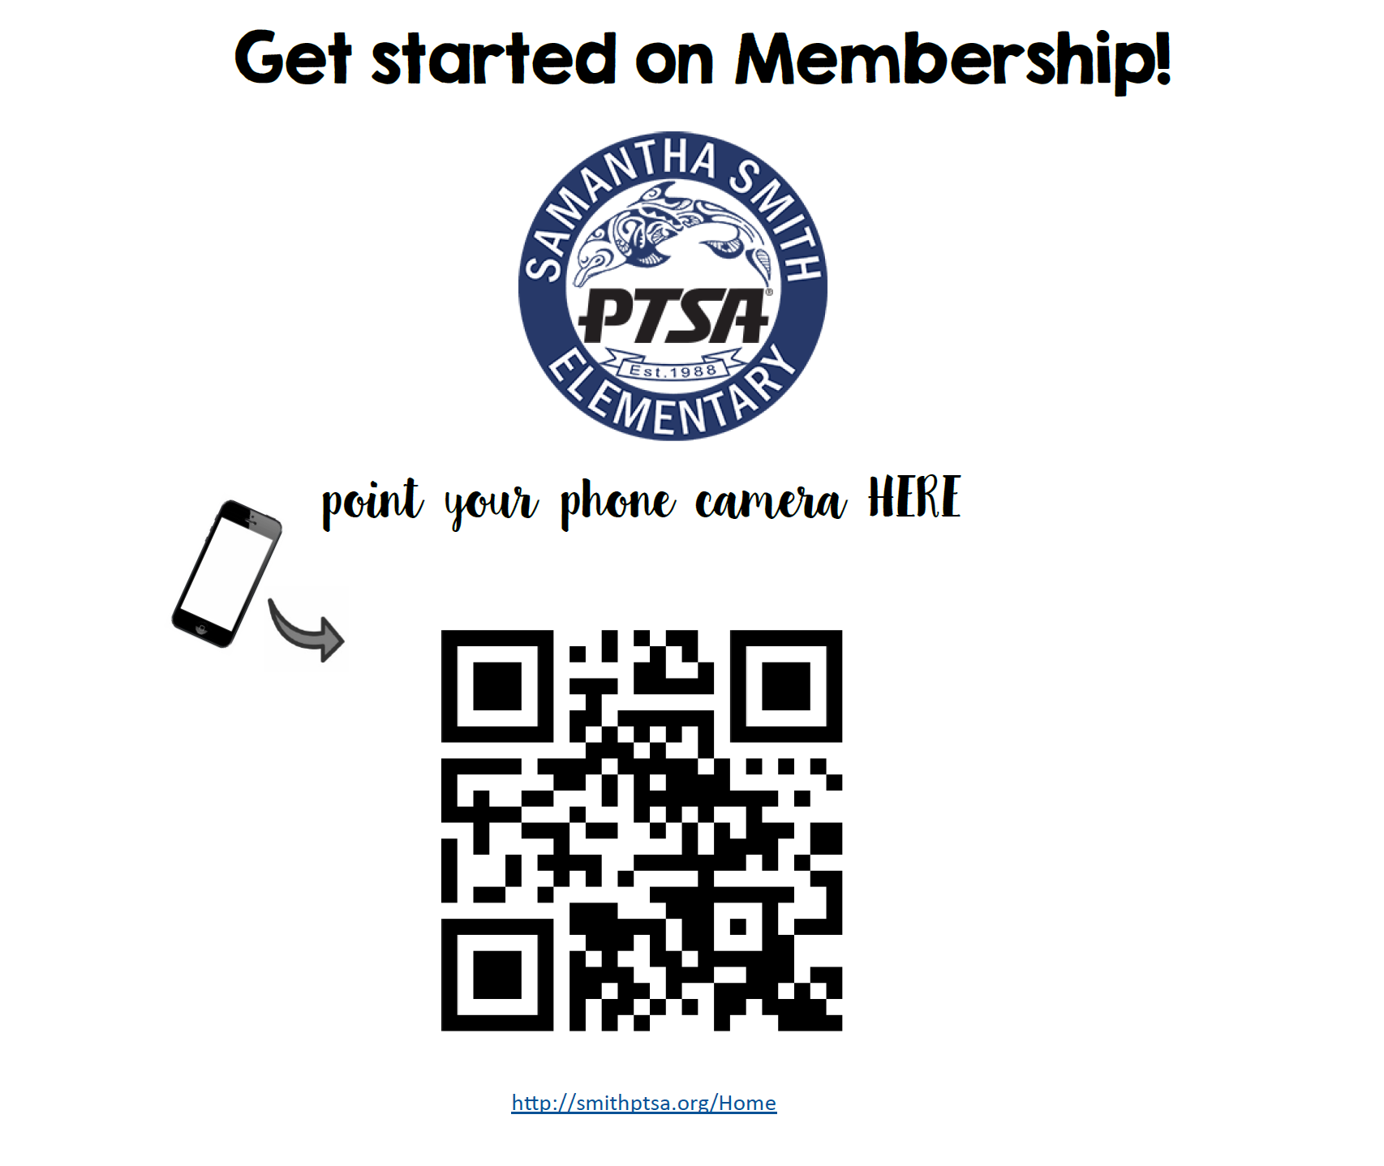
We hope you have a safe and healthy summer! Thank you for continuing to partner with us here at Smith!
Sincerely,
Mrs. Warner
Principal

